Economic Hardship

**Metadata Name:** Foreign-born Regions  
**Last Modified:** February 9, 2023  
**Authors:** Stefan Ilic

### **Data Location:**

Economic hardship is displayed by census tract in Champaign County, IL.

### **Data Source(s) Description:**

All data for this variable was taken from the 2021 American Community Survey 5-Year Estimates at [data.census.gov](https://data.census.gov). Six datasets were used from the ACS, including unemployment (# of unemployed over 16), education (over 25 without HS diploma), per capita income, poverty (# of households below poverty level), crowded housing (housing with more than one person per room), and dependency (population under 18 and over 65). More specifically the codes used were S2301 (unemployment), DP02 (dependency), B15003 (education), S1902 (per capita income), S2501 (crowded housing), and S2201 (poverty).

### **Description of Data Processing:**

The data was first filtered on the Census Bureau’s website and downloaded as a csv where it was then processed in Excel. Because some of the census tracts from the Census Bureau data are divided into two parts, much of the percentages needed to be recalculated to ensure that merging did not have any issues. Once all of the percentages were recalculated, they were moved to a single csv file where the values were normalized on a scale of 0 to 100 and then averaged to get the hardship index. The csv file containing all of the hardship indices was merged to the master shapefile.

### **Key Variable and Definitions:**

HRDSHP = The hardship index (0-100) per census tract

### **Data Limitations:**

The data is coming from the 2021 ACS 5-Year Estimates, so the population estimates might differ slightly from the ones in the master shapefile.

### **Comments/Notes:**

Much of the hardship indices fall in a range between 27 and 40 with a handful of outliers. Census Tract 60 is the lowest in economic hardship at 17.36 and Census Tract 7 is the highest at 58.03.

**Sample Maps:**

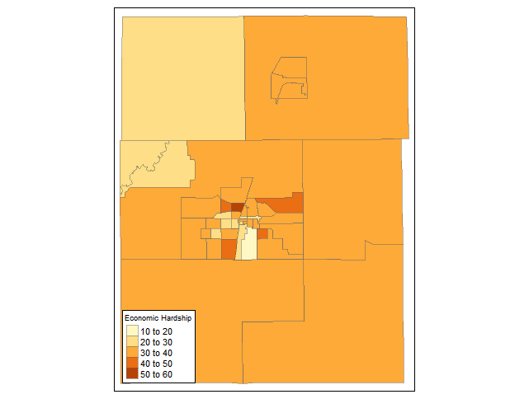

Map showing the economic hardship range per census tract